FINMERGE CAMPAIGN – CONTENT STRATEGY & CREATION

PROJECT DETAILS

Background:
Currently, FINMERGE is able to generate leads digitally via various campaign and they then pass them directly to their sales team for following up with a sales closure call. But they don’t have any way to continuously engage their existing customers - to warm them up to the point where they feel they need to talk to a Financial advisor or Tele sales rep.

Objectives:
Creating a suite of bite-sized and relevant content to educate and nurture FINMERGE customers on their financial awareness that will at right time lead them to purchase an insurance plan through their direct platform or to have an insurance conversation with a Financial advisor or Tele sales rep

Target Audience:
Primary Business: Insurance
Marketing Audience: FINMERGE Customers (3 Segments - Early Career/ Young Families/ Pre-retirees)

Reaction to evoke in the audience of this campaign:
- Better understanding of financial products.
- Receptive and wanting to read financial contents generated from FINMERGE.
- When comes to buying insurance, the FINMERGE channel is what FINMERGE customers will come to.

PURPOSE

Many adults today are financially illiterate as that is not a topic that is typically taught in schools today, resulting in many having little knowledge in managing their finances.

GOAL:

 | Short-term | Long-term
Goal | To make financial topics simple and easy for FINMERGE customer to understand so that they will be keen to learn more. | To warm up FINMERGE customer up to the point where they feel they need to talk to a Financial advisor or Tele sales rep, and eventually they purchase a FINMERGE policy.
Specific end results | - Continuous increase in content views  - Customers looking forward for the next release of the content  - Customers sharing the content with their family and friends | - Customers ready to speak to a FINMERGE agent  - Customers purchase a FINMERGE policy through this channel.

Current Theme & Annual Plan (Example below)

Nurture & Drive Leads

Lead nurturing content is planned regularly with relevant context that resonates with each target customer segment
 | Mar | Apr– Jun | Jul – Sep | Oct – Dec
 | SAVINGS | PROTECTION | CRITICAL ILLNESS | SAVINGS
Early Career | Benefits of building early saving habits | How you can save by protecting yourself early | Being prepared when facing life’s curve bail | How to save on taxes and build your savings
Young Families | Saving with specific goals in mind (Home, child’s education, family vacation etc.) | Protecting your loved ones against life’s uncertainties | Protecting your income and family’s standard of living | How to save on taxes and meet your goals
Pre-retirees | Never too late to start planning for your retirement | Ensuring you leave a legacy for your loved ones | Protecting your hard earned wealth against life’s uncertainties | How to save on taxes and fulfil your retirement goal

- Lead nurture content is a combination of articles (1 min read), videos, infographics, quizzes, product offers & meeting incentives
- FINMERGE drives content consumption via multiple communication channels and remarketing efforts

DELIVERABLES AND FORMATS

Language: UK English

ASK FROM THE CANDIDATE

- Recommend the content strategy and channels that FINMERGE should follow, strategy and its application so as to influence the following metrics:
  - Email Open rates
Ans:
Good email open rates will depend on the following factors
1 – Set the email campaigns only when it’s time for the customers to renew their policy or premium payment is nearby
2 – The email subjects should be in bold and clearly stating that your premium is due or if any non-claim bonus is due
3 – Change the domain every time a mailer is sent to the existing candidates so they don’t tank the domain reputation when they are irritated or moody
4 – Tweak the subject to line and do A/B testing on the open rate last time and the current time, personalization can make a difference and also a little bit of role play for eg. The subject can say Sheila wants to be .... (for men)
A 50% flat off can be... (for women) The subjects wont be complete but it will surely created an intrigue and lead to good open rate

  - Web/Social Media Platform Ad Open rate
Ans:
On social media the ads completely get traction if the content is upfront and engaging
1 – For eg – Interactive video just the mobile ads for games on iOS and Android run in between other games it tempts us to still download a shitty game and play cos the in the ad the one who is playing is doing it wrong and we can’t just take losing in a game that is so easy so ultimately it leads to downloads same goes to social ads
2 – Another thing which intrigues a person to open a social media or web ad is to show something unusual like a hideous pimple on a person’s cheek and where the copy says he pops it out and you won’t imagine what comes out of it. Such click bait option are the only things which will work to get a person to open a Fintech company’s content selling ad \
3 – Another way is to let them open an ad is a prank or an easy quiz who everyone can answer but to answer they will have to see the ad

  - Content views
Ans:
For content views the only thing which really works is boosting the content because am guessing our target audience is not the one who falls into a non working category who will be spending time on social media and until we push them to read something they won’t be spending money to buy a insurance.
Platforms – FB, LI, TW, Instagram, Whatsapp Business, SMS and RCS

  - Click-thrus to the content
Ans:
Offers entice everyone be it a business looking out for expansion or a consumer looking out for groceries. In our case giving a money back SIP option or a part waiver to their next premium is the option to retain the customer and ensure the remarketing efforts are saved behind the existing customer which will increase the click through rate of our content

  - Leads generated from the content
Ans:
Leads generated from a special platform or a piece of content which worked on that platform should be a benchmark and kept as a weapon in our Arsenal and be used from time to time whenever we are short on leads so as to help ROI

  - No. of policies sold
Ans:
Earning professionals (Our TG) always look for how they can get tax rebate or just with a minimum amount of payment how can they enjoy money double benefits which is why certain SIP options just like the LIC of India offers, should be introduced to keep the money coming in from the current customers. The amount of supporting SIPs sold towards a waiver for a next pending renewal of a policy should be counted as a policy sold and should be squared off

- Themes (e.g. Savings, protection, CI): Not limited to (e.g. Savings, protection, CI). We are open for your thoughts to propose the topics what will be more suitable or trending. Most importantly is that it will be something they will resonate with the respective segments and they will want to read the content.
Ans:
Below are a few things which will resonate with the core content themes/modules for Finmerge
1 – Dreams – Talk about the dreams which our 3 category of TG might have - #InsureYourDreams
2 – Care – Talk about what our 3 level TG cares - #CareAndShare
3 – Stories – Share stories which our 3 modules of TG will relate to - #WeAreListening
4 – Support – Be a partner in their joyful as well as sorrowful moments - #WeEmpathise
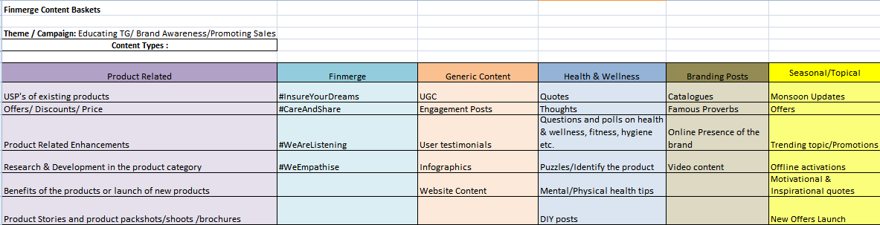

- Duration of theme: Not limited to quarterly basis. Can also be monthly, open for suggestion.
Ans:
The content buckets mentioned above are wider which helps sustenance for more than 3-6 months but the baskets can be bifurcated into a weekly dissemination Product, Finmerge, Generic, Health and wellness and Branding can be a weekly activity so that we don’t repeat content and have variety to talk about and Seasonal/Topical depends on the moment they happen or whatever and whenever its trending and this can run for a whole year long.

- Content type - Below are just some suggestions and not limited to the following:
  - Article - not more than 1 min read as customers will be reading from an app on their mobile devices.
  - Supporting Visuals - Infographics / Short Video / Simple illustrations as reference screenshots will be an added advantage.
- Content tone:
  - Easy reading with simple concepts for layman to understand.
  - Educating FINMERGE customers on financial topics. Not necessary link to a FINMERGE product.
- Output - Provide a deck in a PPT or a PDF format for this assessment along with a schedule of what content would be promoted, when and on which channel [including reasoning thereof]

The success of the content will be assessed on the basis of the below, so kindly provide enough reasoning on how the content strategy and its application populates and influences each of the following metrics:

